**Team 808**



**Fall 2022 + Spring 2023**

# **Contents**

**Section 1 (p.3) -** Revision History For This Document

**Section 2 (p.4) -** Product Overview

**Section 3 (p.8) -** Requirements

**Section 4 (p.11) -** Product Design

**Section 5 (p.22) -** System Design

**Section 6 (p.36) -** Integration Test Results

**Section 7 (p.43) -** Schedule

**Section 8 (p.44) -** Budget

**Section 9 (p.46) -** Acceptance Testing

**Section 10 (p.47) -** Expo

# 

# **1 Revision History For This Document**

| **Version Number** | **Version Date** | **Revision Description** |
| --- | --- | --- |
| 0.1 | 9/8/2022 | First draft, sections 1-2.2.5 added. |
| 0.2 | 10/7/2022 | Section 3 added, changes made to project scope after advisor meetings. Formatting fixed. |
| 0.3 | 11/2/2022 | Section 5 added. |
| 0.4 | 11/10/2022 | Sections 4, 7, and 8 added. Sections 2 and 3 revised, changes reflect design constraints. Formatting fixed. |
| 0.5 | 12/9/2022 | Added sections 3.4, 3.6, and 4.6, and updated existing sections to reflect the project scope. Updated hardware, budget, and risk demos. |
| 0.6 | 3/23/2023 | Added sections 6. Updated sections 3, 4 ,5, 7, to reflect the change of scope with the project and engineering/marketing specs. Updated budget. |
| 0.7 | 5/2/2023 | Added section 10. Updated sections 2, 6, 8, and 9. Applied recommended changes from previous update. Fixed formatting. |

# 

# 

# **2** **Product Overview**

## **2.1** **Project Info**

### **2.1.1** **Project Title**

Scalable Electrosurgical Unit for Controlling and Powering the Ligasure Dissection Device

### **2.1.2** **Product Title**

Electrosurgical Unit System

### **2.1.3** **Sponsor**

Medtronic

### **2.1.4** **Technical Advisor**

Keith Malang

### **2.1.5** **Your Supervisor**

Gabe Altman

### **2.1.6** **Team Name**

808

### 

### **2.1.7** **Team members, roles, responsibilities**

**Sonal Tamrakar Team Lead/PCB Design Specialist**

-Manages team responsibilities and roles

-Lead PCB design by using Altium and other resources

-Makes final decisions if there is uncertainty

**Rustin Chang Hardware Lead**

-Leads hardware efforts, integrates whole design

-Debug/Test/Troubleshoot Hardware issues that arise

-Runs simulations/CAD/hardware development applications

**Ali Moran Product Manual Editor/Software Team**

-Ensures consistent style and format throughout PM

-Updates PM revision history as others make changes

-Edit PM for clarity and spelling

-GUI specific software development

**Chengming Li Software Lead**

-Software development

-Holds all repositories for code using GitHub

-Software architecture design

**Daniel Chun Financial Manager/Morale Manager/Hardware Team**

-Bookkeeper of all costs spent on the project

-Record all costs spent on non-project-related activities involving the capstone group

**Noah Zhao Communications Manager/Hardware Team**

-In charge of communication with our sponsor and organizing meetings

-Responsible for communicating immediate updates and needs to TA mentor

**2.2** **Elevator Pitch**

An electrosurgical device, or ESU, is a surgical incision device used to incise and remove organic tissue efficiently while controlling bleeding. As it currently stands, ESUs are inaccessible to many parts of the world due to their power generator’s steep cost and large size. Our product is a smaller, less expensive ESU, a complete system with a generator, which runs off of a DC external power supply. A portable, relatively cheap generator that connects to pre-existing Ligasure devices reliably provides the electrical signals and control functions required by the ESUs, which along with a clear guided user interface makes this ESU system accessible to medical professionals worldwide.

## **2.3 The Problem Your Product Solves**

### **2.3.1** **The Big Picture**

There is much disparity between the medical technology that different countries have access to. People everywhere deserve the best healthcare available, and this technology gap is preventing that. In order to rectify this, relevant tech must be made accessible to countries that cannot afford the high prices of current equipment through alternatives. Having different operating room setups which may not integrate technology from different parts of the world smoothly is another problem which must be addressed, and could be solved with tech alternatives.

### **2.3.2** **How Your Product Fits Into This Overall Solution**

Developing countries do not have access to the same medical technology which is saving lives in other parts of the world. To rectify a part of this issue, the ESU acts as a replacement for the expensive, bulky generators currently in use.

### 

### **2.3.3** **Your Vision Of What Your Product Will Do When You Are Done**

The ESU is a scalable small form factor generator that drives an existing LigaSure device from Medtronic. The generator is powered by an AC wall socket, and, as a tabletop device, can rest on either a fixed table or a small rolling table as applicable to operating theater requirements. The generator is composed of a controlling processor which generates a fixed 430KHz RF tone delivering 50 Watts. This generator produces a peak voltage of 115 Volts and a peak current of 3-4 Amps. Using current and voltage sensors, the ESU measures the current and voltage to get the average power running in the system. The data taken by the sensors will output to a Python-based GUI on a user's computer, and the chassis has built in buttons for power and emergency stop. Compared to the larger generators already developed by Medtronic, this ESU is more accessible to third-world countries in order to provide access to LigaSure technology in hospitals around the globe.

### **2.3.4** **Who is the customer**

The sponsor for the ESU generator is Medtronic, but the users are medical professionals worldwide, with a focus on those from developing countries. Due to cultural and language barriers, the generator has a very simple user interface with clear tones delineating the start/stop of a cycle, an error tone, and a power button labeled with an image instead of words. The GUI is similarly simple, and while it needs to use English words they are all basic and relatively easy to parse.

### **2.3.5** **What are a few of the killer apps**

The ESU device can efficiently transect tissue while also sealing blood vessels, preventing blood loss and circumventing the need for other vessel sealing methods that carry higher risks of infection and insertion of foreign bodies within the patient. It allows for fast, clean tissue and organ removal. The generator required to power this device is smaller than pre-existing ones to be less of an obstruction in the operating theater. The size, coupled with its light weight makes it portable, allowing for easy shipment and transfer between hospitals and other necessary locations. It is cheaper than other existing generators currently in use.

# 

# **3 Requirements**

## **3.1 Marketing requirements**

| **Number** | **Marketing Requirements from Customer** | **Importance Rating: High, Medium, Low** | **Acceptance notes** |
| --- | --- | --- | --- |
| 1 | Small Form Factor (8x16 inches) | High | Three target customers should place the unit within their surgery rooms to see if the size of the unit is acceptable. |
| 2 | Provide 324-334 volts peak to peak voltage at the output of the transformer | Medium | Provide the user with enough voltage to drive the system |
| 3 | Delivers 50 +- 10% Watts to a 500 Ohm resistive load of RF power (430 kHz) to drive a Ligasure device. | High | Measure RF power draw using an oscilloscope to ensure the 50 Watts of power is being delivered at ~430 kHz |
| 4 | Provides data stream from current and voltage sensors located at the output of the system. Repeatedly samples voltage and current. | High | Provide the user with voltage, and current measurements for debugging. Also provide voltage and current RMS values for impedance calculations in future past this project’s scope. |

## 

## **3.2 Who are the intended end users and how will they use the product?**

The intended end users are medical professionals in low/middle income countries performing surgery on patients. The surgeon can plug in whichever Ligasure device they need to use for a given procedure into the generator, the device starts up, and then outputs to a screen whether or not it’s ready to cauterize.

## 

## **3.3 Use cases**

The user plugs the generator into a wall and their computer and turns it on with the laptop. The generator powers up and the user plugs in the Ligasure device. The generator then starts to supply power to the Ligasure device. Once ready to begin a cauterization cycle, the generator outputs onto the computer screen an image telling the user to begin, as well as a specific tone indicating readiness. The user can then proceed with the cycle, cutting and cauterizing the tissue. While the cycle is underway, the device repeatedly samples the voltage and current across the load to calculate average power, allowing it to monitor how power changes with many known impedance resistors. The average, along with the voltage and current measurements, will be fed into the computer where the user may choose to generate a spreadsheet and/or a graph of the data. After the operation is done, the user will unplug the Ligasure device and dispose of it as directed. After all processes are complete the user can then turn off the generator and move it back to storage.

## **3.4 Safety Concerns**

When live, the ligature device will be pushing 50 W of power through its jaws. If handled incorrectly, this could cause very serious injury. Another concern is if a cauterization cycle completes and the generator fails to cease power output for any reason, the patient could receive charring or other burns when the device is removed. The solution to this is to run the system on a duty cycle by the person handling this. If the device were to run for 40 seconds, a 25% duty cycle would mean the user would have the system on for 10 seconds and off for 30 seconds.

**3.4.1 Grounding Concern**

When the device is in practical use, the patient will be on the operating table which might be grounded. The power supply of the SESU will be connected to earth ground as well as the device (laptop) that turns on the electrosurgical unit. We need to ensure that the system output is isolated from the rest of the circuit which is why an isolation transformer is used. An isolation transformer ensures that the RF signal has only one return path (the return line) such that the active signal won’t be grounded through the patient.

## 

## **3.5 Engineering requirements**

| **Number corresponding to Marketing Requirements** | **What must be done** | **Explanation** | **Acceptance Notes** |
| --- | --- | --- | --- |
| 4 | - We will have to construct both current and voltage sensors on the output of the system that measures the RMS values of voltage and current at open loop.  - This data feedback from the ESU must be digitized using a TI Piccolo  -Data are sampled at least 3.45M samples/ second | - The current and voltage sensors will allow for easy access to verify the measurements of the RMs values for debug purposes  - The TI Piccolo family provides fast A/D rate allowing the rate of of 8 samples per cycle | -Compare RMS values from the current and voltage sensors with calculated RMS values of a oscilloscope. |
| 3, 2 | The ESU is composed mainly of a controlling Processor  - Will generate a fixed 430 kHz RF Tone delivering at most 50 watts(+-10%)  - Peak Voltages on the order of 160v (+- 10%, peak-to-peak).  - Converts DC to AC Power Inverter (Phase Shifted Full Bridge Topology) | - 50 Watts is required for 5mm tissue incision  - 50 Watts of power is designed for smaller Ligasure devices meaning lower cost for the Ligasure device itself and a smaller ESU to drive the device. | -Measure the RF tone signals and delivered power using an oscilloscope and resistive loads |
| 4 | - Output this data on a python-based GUI | - A user interface with ease of use and simple features are desired to enable medical experts to analyze the cauterization data firsthand and real-time | - Compare our data with oscilloscope values (RMS) and what we are reading on the ADC of our processor |
| 4 | - Use a microcontroller from the TI Piccolo family | - This is a legacy design constraint, as Medtronic has been working with these on similar projects | - Read samples for voltage and current that match the oscope output  - Calculate the voltage and current RMS values from the samples |

## **3.6 Minimum Viable Requirement**

At the minimum, our product (the ESU generator) must be able to complete the system consisting of the generator itself in connection with a wall socket, a ligature device, and a computer. The generator must provide the necessary 50 W +- 10% of power to our functioning system which includes the DC power supply, phase shifted full bridge, and the RF tank + filtering circuit. The DC power supply must feed into the full bridge, which outputs a square wave into the RF tank, which delivers the final sinusoidal wave to the ligature device. The voltage and current sensors in the system must also be working, and both successfully feed their data into the microcontroller and Python GUI on the connected computer for user viewing.

**4 Product Design**

## **4.1 System Diagram**

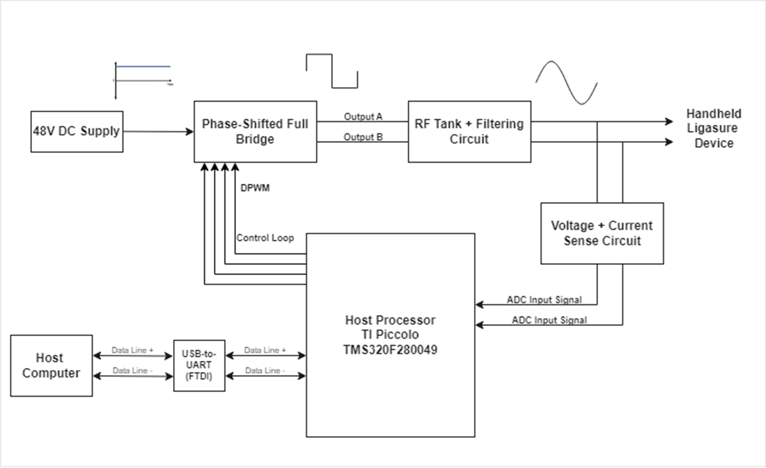

## **4.2 Technology**

**Hardware:**

* Microcontroller: TI Piccolo 280049C
* MOSFETs: TK3R2E06PL
* Gate Drivers: LM5101AMR/NOPB
* Wall power converter: SoulBay 3V - 12V AC wall adapter
* DROK 48V DC power supply
* LigaSure surgical ligasure device
* Op Amps: AD8031ARZ

**Software:**

* TMS320F280049C
  + Development board for testing code
* 3 12 bit ADC
  + 3.45-MSPS
  + 8 samples/cycle
  + 1. Voltage sensor
  + 2. Current Sensor
* 3 PWMs
  + Run at 430 Khz
  + 1. PWM 5A and 5B, 0 phase degree
  + 2. PWM 6A and 6B, 180 phase shift degree, based on PWM5A and 5B
  + 3. PWM 4A and 4B, stay HIGH
* UART
  + control the PWM on/off and phase shift
* Control Law Accelerator (CLA),act like second CPU on chip
  + Executes code independently of main CPU
  + ADC and PWM will run in this core
* Direct Memory Access (DMA)
  + Retrieve ADC data from the RAM
* Putty
  + Serial Port
* GUI (Python)
  + Display the real time data (Voltage and Current RMS, and Average Power, Samples plot )

## **4.3 Initial Schematics/Diagrams**

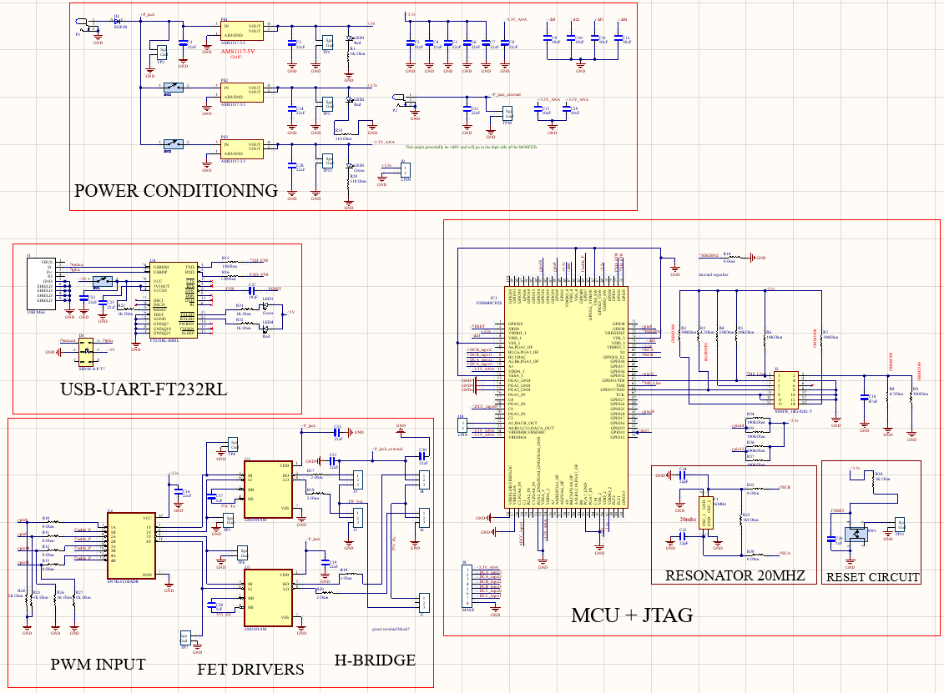

**Figure:** Custom MCU evaluation board with added features such as the FET drivers + FETs

## **4.4 Phase 1 Design & Proof of Concept Results**

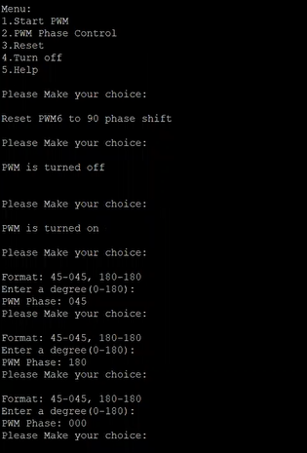

**Figure**: PWM phase control displayed in Putty

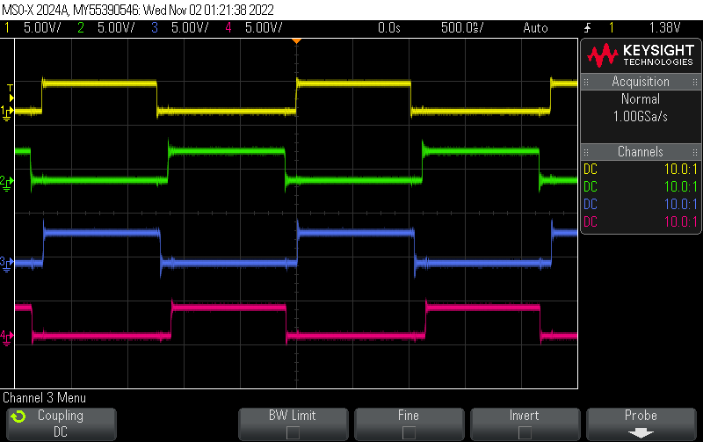

**Figure:** Four PWM signals generated from custom PCB with appropriate deadtimes

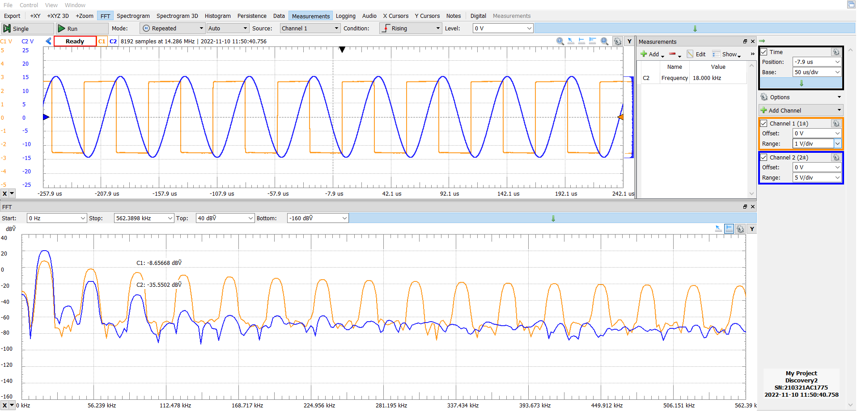

**Figure**: Resonant tank measurements on Analog Discovery 2 (implemented on SBB) indicating a working tank design

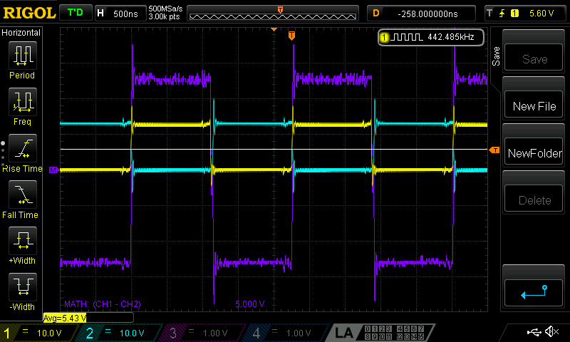

**Figure:** Output from the phase-shifted full bridge (in purple), which is the difference between the yellow and the light blue trace using the math function on the scope. The measurements are generated from the custom PCB.

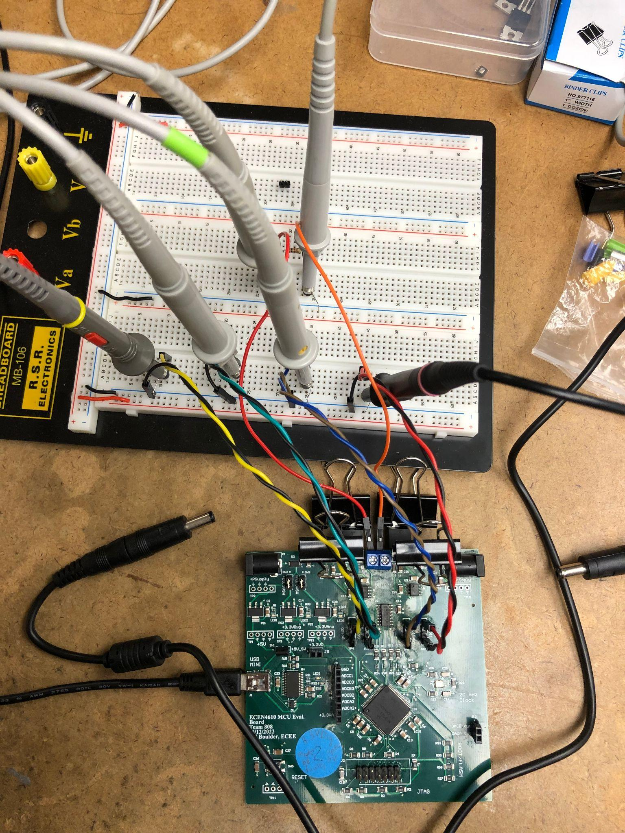

**Figure:** The figure above shows the phase-shifted full bridge setup where the 4 PWM signals are broken out onto the breadboard in order to measure them. The phase-shifted full bridge is then connected across a load and the output is measured using two probes.

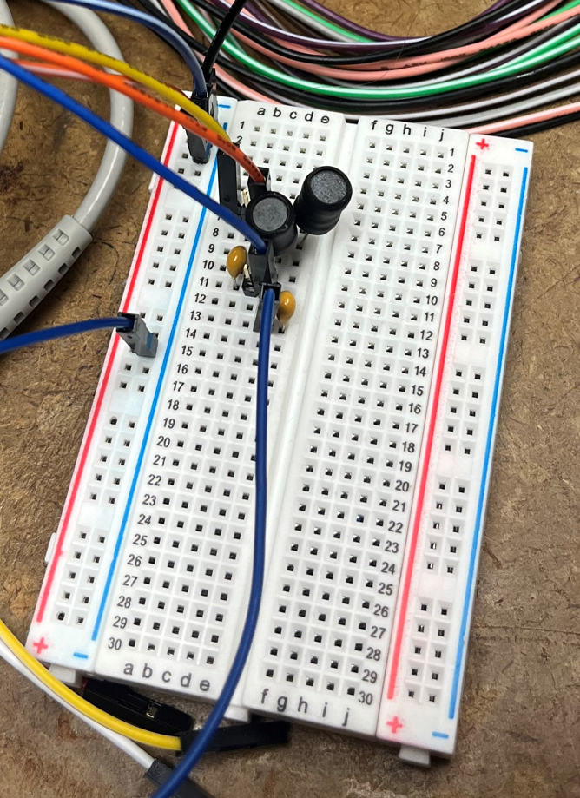

**Figure**: First prototype of a resonant tank implemented on a breadboard. The input waveform is from the Analog Discovery 2.

**4.5 Phase 2 Design & Proof of Concept Results**

**PWM Synchronization:**

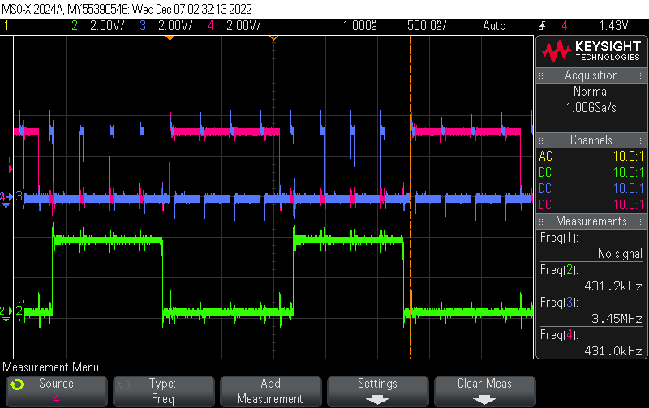

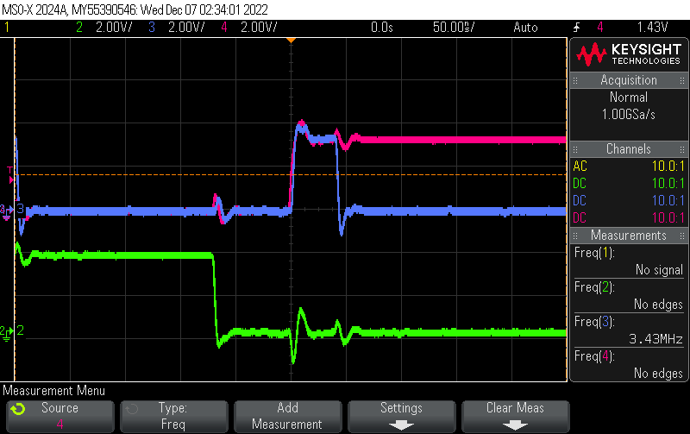

**Figures:** PWM Synchronization

The blue trace is the PWM used to start the ADC conversion at 3.45 M samples per second. The pink and green trace is the PWM used to send to the phase controlled full bridge at 430kHZ. There will be 8 ADC samples/ pulses per cycle (430kHZ). As seen in the above picture, there are 8 blue pulses in 1 green pulse. And every 1st blue trace starts at the same time with the pink pulse.

**Voltage Sensor:**

**Figure:** LTSpice schematic of the voltage sensor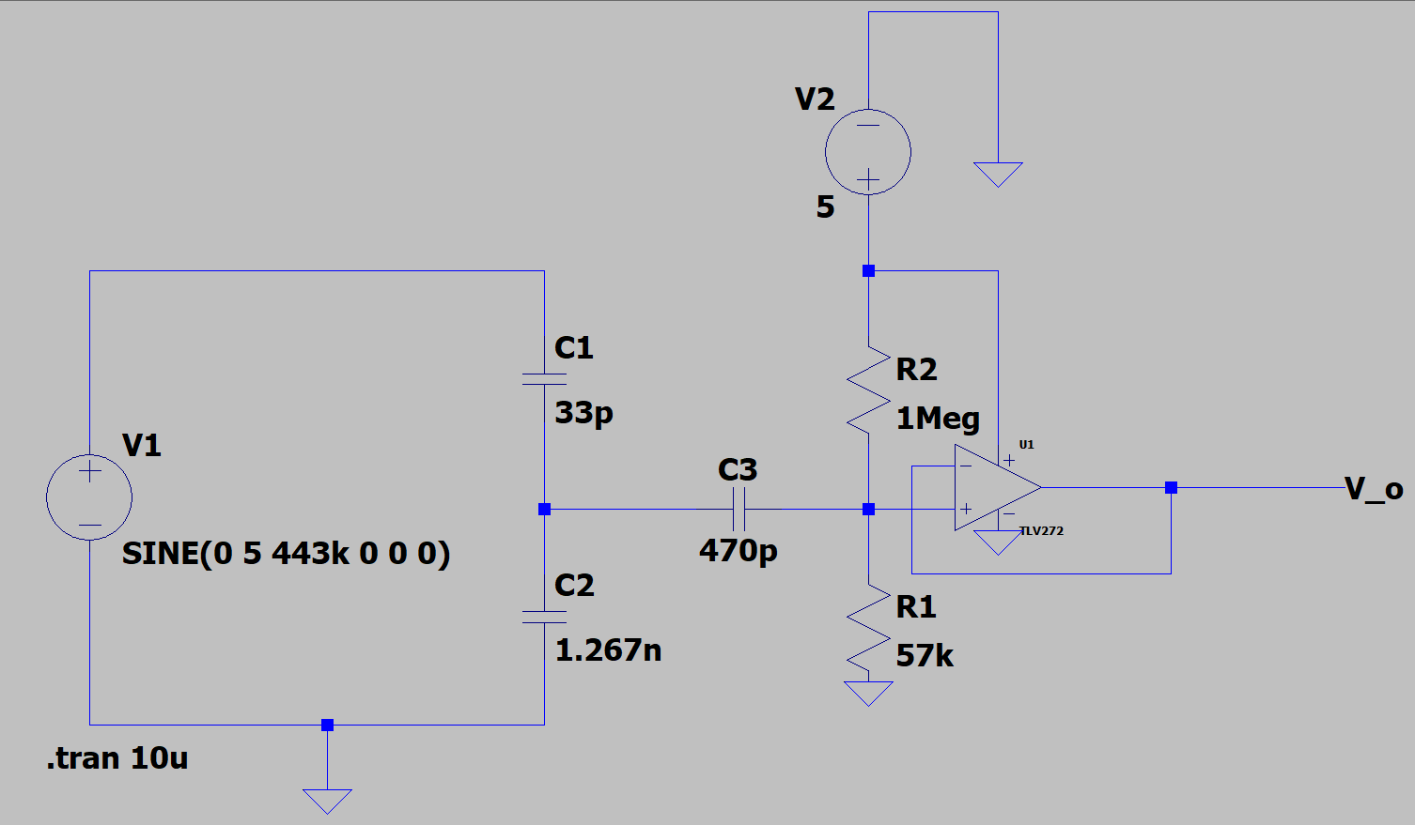

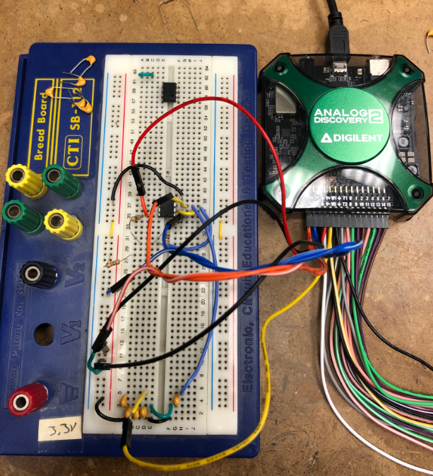

**< Figure:** Breadboarded voltage sensor hooked up to the AD2 waveform generator. With a known waveform as the input, circuit testing relied on the probed output matching calculated values.

**^ Figure:** Waveforms generated by the AD2 and voltage sensor during testing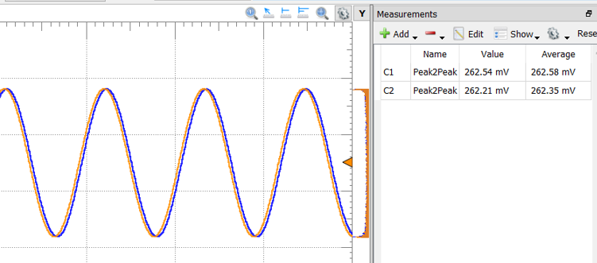

**5 System Design**

## **5.1 Risk Sites**

### **5.1.1** **Microcontroller**

The microcontroller we are using is part of the TI Piccolo series, specifically the TMS320F280049 (IC MCU 32BIT 64KB FLASH 48LQFP). There is low stock of this as it is not a relatively common microcontroller and there is a chip shortage, but we were able to get 5. However, if we run into issues with these, such as a current spike because of faulty board design rendering them inoperable, it would be a challenge to get more in a timely manner. A design constraint of our project is having a microcontroller with a high sampling speed, and this one meets our requirement of 8 samples per procedure cycle from our system (sampling rate of approximately 3.45 MSPS).

To mitigate the risk, we have selected two alternative microcontrollers to fall back on if the TI Piccolo fails. The first is the Infineon PSOC. It requires knowledge of a different design interface which is risky by itself, but by preemptively learning the software using this chip shouldn’t set our schedule back. It has a lower sampling speed so we would have to work around this by adjusting the way samples are taken and graphed, by taking less samples per cycle but combining them with other samples taken out of phase in concurrent cycles to imitate a higher sampling rate. Another alternative would be to use the Arduino ATMEGA, as this one is easy to use and our group has experience with the software necessary, but this also has the same issue of a lower sampling rate.

### 

### **5.1.2** **Resonant Tank/Magnetics Design**

The ESU contains a resonant tank that is responsible for filtering and creating the constant 430 kHz tone required for proper cauterization. Resonant tanks and magnetics are fields which no members of our group were familiar with. Since our project was required to deliver a 324-333(+-10%)V peak-to-peak sinusoidal tone from a square wave, we were required to design - high-frequency filters and design custom inductors and transformers to achieve our custom specifications.

Our group began the design process on our own but quickly fell back onto our first backup plan, which was to leverage the help of power experts within CU’s electrical engineering department to receive guidance. Our second plan was to purchase an off-the-shelf tank if our design completely failed, but we did not end up needing to do this. The last option posed its own risks, in that even if it circumvented the need to design our own tank, it would be hard to find a pre-existing design that both matches the design constraints inherent to the finished product and also is in stock and ships in a timely manner.

As stated previously, another risk that the resonant tank poses is the need to wind custom transformers which the team has never done before, and the possibility of specific component values not being readily available for use when implementing the design.

### 

### **Figure:** Altium Schematic containing Resonant Tank

### **5.1.4** **ESU Frame Design**

For the frame which will house our ESU circuitry and interface, a custom acrylic, laser-cut box would be ideal. We will use the MakerCase website which will allow us to input custom dimensions for our enclosure and it will give us a file containing all the information of our enclosure making laser cutting each wall easy. Below is a screenshot from the MakerCase website of what our enclosure will look like.

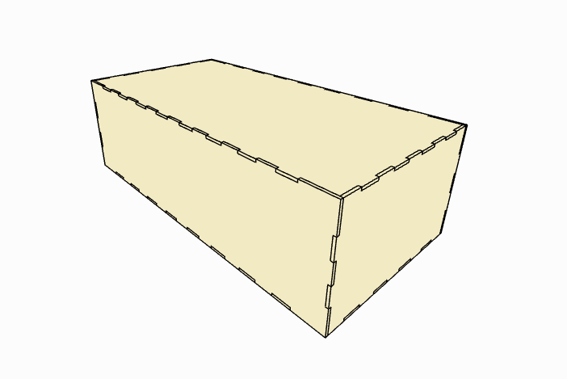

Since the design of this must be adjusted as our project develops, we have plans to fabricate this at the very end of our design process which poses the risk of our team running out of time to design and drill the correct holes before EXPO. If we have the time, we will allocate enough to make a frame that is as perfect of a fit as possible.

**5.2 Design/Test Demos**

### **5.2.1** **Microcontroller**

To test the functionality of the TI Piccolo microcontroller, it was necessary to confirm the flash upload as well as the bipolar square wave generation. Meanwhile, the conversion frequency of the ADC is synchronized with the PWM frequency, as 430kHz. And 8 samples per cycle data can be retrieved both from ADC A (voltage sensor’s input) and ADC B (current sensor’s input).

To set up the tests, Infineon PSOC is used. In order to demonstrate Infineon PSOC's viability, it was essential that we confirm the ~430kHz square wave is generated by the PWM. In addition, the phase control function needed to be created and verified. Example: PWM 2 is phase shifting to some degrees based on PWM 1. Beyond that, the functionality of ADC needs to be verified as well, for example, the conversion frequency of ADC is synchronized with the PWM frequency, and voltage and current sensor’ input are retrieved from the ADC within the range from 0-3.3V.

**5.2.2**  **Resonant Tank Design**

**Functionality:**

* Filter out non-fundamental harmonics of input 48 V peak bipolar phase-shifted square wave from the phase-shifted full bridge
* Deliver a 324-333 V peak-peak output from the step-up transformer

**System Diagram:**

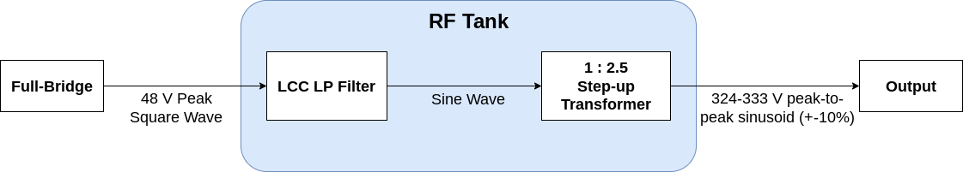

**Figure:** System diagram simply explaining the function hierarchy of the RF Tank

**Design Process:**

1. **LCC Low Pass Filter Design Process:**

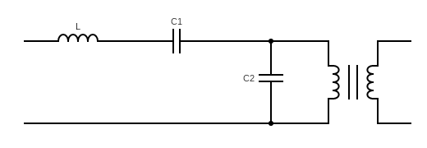

*I. Calculating Specifications:*

First the open circuit transfer function H∞(S) where R→∞ was computed, which gave insight to how the magnitude of the output voltage depends on the load current. Then using the transfer function the peak voltage at the nominal operating point (163 volts) was computed followed by the peak current at the nominal operating point (0.614 Amps): note, these output parameters were calculated with the 2.5 turns ratio step-up transformer pushed through. Using the peak current at the nominal operating point, peak voltage at the nominal operating point, and open circuit voltage value, the short circuit current value was calculated.

*II. Impedance Voltage Divider Ratio:*

Therefore, once the open circuit and short circuit specifications had been calculated, the necessary impedance of the series and parallel branches of the LCC network were calculated which led to the output impedance given by the series and parallel branches of the LCC network. Therefore, in doing so, we now had the first design equation for calculating the series LC and parallel output C (impedance voltage divider) to give us our necessary open circuit voltage and short circuit current parameter.

${jX}_{s}: Impedance of series capacitor and inductor$

$jX_{p}: Impedance of parallel output capacitor$

$V_{out}=V_{in}\frac{jX_{p}}{jX_{s}+jX_{p}}$

$jX_{p}=\frac{1}{C_{2}s}$ (equation 1)

$jX_{s}=sL +\frac{1}{C_{1}s}$ (equation 2)

*III. Frequency Response:*

Our second design constraint would be the frequency response in which we were designing for a resonance (cutoff frequency) at the second harmonic (860 kHz).

$V_{out} =V_{In} \left(\frac{\frac{1}{sC_{2}}}{\frac{1}{sC_{1}} + \frac{1}{sC_{2}} + sL}\right)=>\frac{1}{sC_{2}\left(\frac{1}{sC_{1}} + \frac{1}{sC_{2}} + sL\right)}=>\frac{1}{1+ \frac{C_{2}}{C_{1}} + s^{2}C_{2}L}$

$=>\frac{1}{\frac{C_{1}+C_{2}}{C_{1}} + s^{2}C_{2}L}=>\left(\frac{C_{1}}{C_{1}+C_{2}}\right) \frac{1}{s^{2}\left(\frac{C_{1}C_{2} L}{C_{1}+C_{2}}\right) + 1} =>\left(\frac{C_{1}}{C_{1 }+ C_{2}}\right) \frac{1}{s^{2}\left(C_{1}||C_{2} L\right) + 1}$

$ω_{0}=\sqrt{\frac{1}{C_{1}||C_{2} L}}$

$f_{0}=\left(\frac{1}{2π}\right)\sqrt{\frac{1}{C_{1}||C_{2} L}}$ (equation 3)

Therefore, by using these two design constraints (using equations 1, 2, 3), we calculated the following values for our LCC filter.

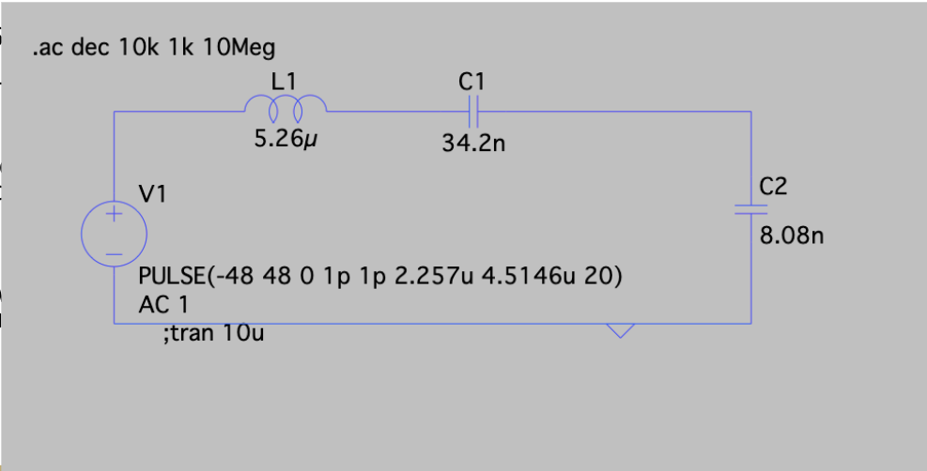

**Figure:** LTSpice simulation of Resonant Tank

*IV. Technology Used*

Since we were utilizing non-standard values for our capacitors, we decided to place 4 capacitors in parallel in place for the series capacitor and 2 capacitors in parallel in place for the output parallel capacitor.

In regards to ratings, the main concern for the 4 capacitors in place of the series capacitor would be most concerned with the short circuit current. Meanwhile, the main concern for the 2 capacitors in parallel would be the open circuit voltage as most current would travel through the short circuit created by the step-up transformer. The following were the critical parameters for our capacitors:

Series Capacitor (4 capacitors in parallel):

* Secondary side specifications:

5.5 A RMS (account for 10% swing)

* Primary side specifications

$I_{sc}=2.5*5.5 A =13.75 A (RMS)$

Using a 25% duty cycle estimation, we found that our final short circuit current was approximately $3.4375 A (RMS)$

In regards to our open circuit voltage, based on the Fourier series derivation of our phase-shifted square wave input, the maximum open circuit voltage of our LCC LP Filter would be approximately 61.12 V.

Thus, based on these specifications, we utilized the following film capacitors:

* Series capacitor
  + 3x: 8200 pF (part ID: B32672L1822J000)
  + 1x: 10000 pF (part ID: B32672L1103J000)
* Output parallel capacitor
  + 1x: 4700 pF (part ID: B32672L8472J000)
  + 1x: 3300 pF (part ID: B32672L8332J000)

1. **Inductor Design Process:**

*I: Design Process*

For our custom inductor, the two design constraints that we were concerned with was inductance and saturation.

$λ_{1}: Volt-seconds$

$f = 430 kHz$

$V_{pk}(primary)=61.12 V$

$\int_{0}^{T/2}{}V_{pk}sin(2πft)dt=\frac{V_{pk}}{πf}$

$\frac{V_{pk}}{πf}=λ_{1}(Volt-seconds)$

Condition for Saturation:

$λ_{1}<n*2ΔB*A_{c}$

$\frac{V_{pk}}{πf}<n*2ΔB*A_{c}$

Inductance (based on the equivalent magnetic circuit of our core):

$L=\frac{μ_{0}A_{C}n^{2}}{{2l}_{g}}$

The area of the core utilized was 162 $mm^{2}$ in which the variable values were the air gap and number of turns (as long as the number of turns exceeded the saturation threshold value).

*II. Technology Used:*

* Core
  + Part ID: PQ35/35-3F36
* Bobbin
  + CPV-PQ35/35-1S-12P-Z

1. **Step-up Transformer Design Process:**

*I. Design:*

The main design constraint of our transformer was to ensure that our transformer would not saturate. The following process would be used to calculate our necessary turns ratio:

$λ_{1}<n*2ΔB*A_{c}$

$\frac{V_{pk}}{πf}<n*2ΔB*A_{c}$

Therefore, using the specifications of our core, we decided to use a turns ratio of 8:20 to achieve a 2.5 step-up of the output of our RF Tank.

*II. Technology Used: (same as the inductor)*

1. **Test Plan:**

To test the resonant tank design, the full-bridge output will be fed to the resonant tank. The resonant tank should attenuate the non-fundamental harmonics of the input square wave. This filtration of the higher harmonics should be able to produce a sinusoidal wave at a constant 430 kHz tone. The sinusoidal wave should then give the highest voltage at the resonance where the inductive and capacitive reactances cancel each other by being 180 degrees apart in phase. The sinusoidal output from the resonant tank will then be fed to the step-up transformer in which the user will see a voltage output of 324-333 volts (+-10%) with a 48 V DC supply.

**5.2.3 Voltage and Current Sensors**

**Functionality:** Our sensor must be able to read the voltage and current across the load clamped by the ligasure jaws and feed that information back to our ADC. Our ADC can only accept voltages that are 0-3.3V. Hence, the voltage and current sensors must sufficiently scale down the signals that are being delivered to our load so they can be processed by our ADC.

**System Diagrams:**

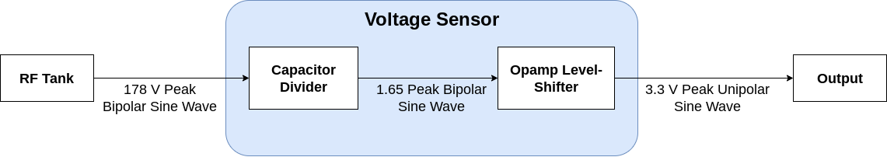

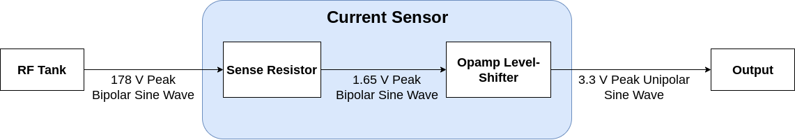

**Figure:** System diagram for voltage and current sensors

**Design Process:**

1. **Voltage Sensor**

*1. Capacitor Divider and Op Amp Topology:*

The necessary ratio for the capacitor divider was approximately 100:1. Furthermore, another design constraint was with regards to an LP response created by the output capacitor of the capacitor divider and the input resistor connected to the negative terminal of the opamp. Therefore, as the resistor was set to 10 k $Ω$, we found that our necessary ratio would be achieved with the following values:



$C_{1}=15pF$

$C_{2}=1.6nF$

The opamp topology utilized was a unity gain inverting opamp in which 1.65 V DC would be biased at the positive terminal of our opamp. This would act as the V+ value of our opamp and would act as the offset that would create a unipolar output.

Furthermore, based on the fact that the Fourier series harmonic composition of the square wave output of the phase-shifted full-bridge will change every time the duty cycle of the square wave is changed through the microcontroller, we needed to ensure that our sensor circuit topology had a frequency response that had an approximate -40dB (approximately 100:1 ratio given the capacitor divider) gain at all possible harmonic frequencies that may be present in the signal delivered to the load. The following is the FS derivation of our phase-shifted full-bridge which is dependent on the input phase value in the microcontroller driving the gate signals of our phase-shifted full-bridge.

$θ_{degrees}:$ Cphase (the phase value input into our microcontroller)

$t_{on}$ (the on period for the output square wave of our full-bridge) $=\frac{θ_{radians}}{ω_{switching}}$

$\sum_{n=1,3,5...}^{∞}{}\frac{4V_{g}}{nπ}sin\left(\frac{nθ_{degrees}}{2}\right)cos\left(nω_{switch}t\right)$

We found that non-trivial elements of the third harmonic would remain even after attenuation from the LCC LP filter. Therefore, we designed a HP response at around the 5th harmonic 1.29Mhz to ensure that we had an approximate -40dB gain at the 3rd harmonic. This was achieved by placing a $6.2$ nF capacitor in parallel with the 10 k $Ω$ feedback resistor of the opamp.

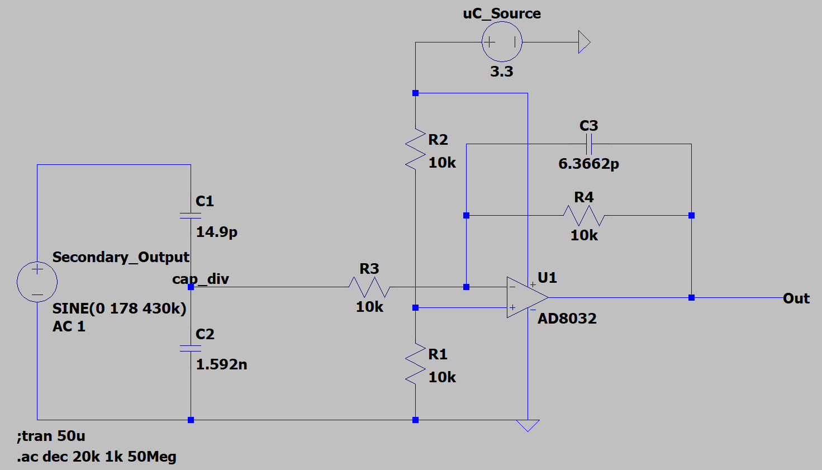

**Figure:** LTSpice schematic of the voltage sensor

*II. Technology Used:*

Capacitors:

* 15 pF (part ID: 12062A150JAT2A): 1206 ceramic capacitor with 200V DC rating (absolute max 177V biasing, current negligible)
* 1.6 nF (part ID: GRM3195C2A162JA01D): 1206 ceramic capacitor with 100V DC rating (absolute max 1.65V biasing, current negligible)
* 6.2 nF (part ID: 12065A6R2CAT2A): 1206 ceramic capacitor with 200V DC rating (absolute max 1.65V biasing, current negligible)

Resistor:

* 10 k $Ω$ (part ID: HRG3216P-1002-D-T1)

Opamp:

* AD8031 (80MHz GBW opamp, operational frequency at 430kHZ)

1. **Current Sensor:**

*I. Design Process:*

The current would be calculated by the microcontroller using voltage measurements read across a sense resistor in which the high side of the resistor would be grounded to the circuit ground. Therefore, we needed a sense resistor that would provide a maximum 1.65 V drop given the peak possible current (5.5 A RMS => 7.78 A peak). Therefore, using Ohm's Law, it was found that a 200 m $Ω$ sense resistor that dissipates a minimum of 10W would be needed. The same opamp topology used for the voltage sensor was implemented for the buffer between our circuit and ADC.

*II. Technology Used:*

Sense Resistor:

* 200m $Ω$ (part ID: PF2203-0R2F1): Rated for 35W dissipation (absolute maximum power dissipation of 12.1W)

Op Amp Topology:

* Same components as voltage sensor

1. **Test Plan**
2. *Voltage Sensor*

In order to test the voltage sensor, any amplitude of voltage can be input into the capacitor divider and the output of the sensor should be approximately 100:1 (gain of approximately -40 dB) to the original amplitude of the input signal. Furthermore, since we are using an inverting topology, the output signal should be a scaled-down (100:1) and an inverted version of the input.

1. *Current Sensor*

To test the current sensor’s functionality, we must connect a load with a known impedance value. Once an input signal is fed into our circuit, the voltage measurements from the current sensor should equal the actual current flowing through our load when divided by the value of our sense resistor ($V/R_{sense}$).

**5.2.4 Synchronized PWM**

**Risk-site to be addressed:** In order to know when a system cycle is complete, we will be measuring the voltage across the load and using it as an input for both of our sensors (current and voltage). Using those measurements, we will calculate the average power of the tissue/load as it changes throughout the cycle point by point. Here, we will be testing the synchronization of PWM because if it is not working, we cannot get the correct current, voltage, average power, and point-by-point calculation at the same time as the uC starts to pulse.

**Functionality:** Our synchronized PWM will be sent to the phase controlled full bridge and used to start the conversion of ADC for both the voltage and current reading. Two different frequency PWMs will be used. 430kHZ PWM will be used for the phase controlled full bridge and the RF tank to generate power. 430kHz * 8 = 3.45MHz will be used for the ADC conversion, and 8 samples per cycle will be achieved.

**Justification:** The synchronized PWM is a crucial part of getting accurate measurements from the voltage and current sensors. We need to make sure that the voltage, current, and average power values are synchronized with the PWM used in the phase controlled full bridge. For example, the voltage, current, and average power values will be measured when the power is sent to the external Ligasure dissection device. In addition, 8 samples per cycle can’t be achieved if two PWM signals are not synchronized.

**Preconditions Outline:** 430kHZ PWM output will be routed to gpio8 (PIN 38 on board). 3.45MHz PWM output will be routed to gpio0 (PIN 60 on board). The two PWM outputs from the uC will be connected to the oscilloscope. A 430kHZ PWM will be connected to Channel 1. A 3.45MHz PWM will be connected to Channel 2. Both channels will be grounded to the GND.

**Expected Steps Outline:**

* Route the 430kHZ PWM output to gpio8 (PIN 38 on board)
* Route the 3.45MHz PWM output to gpio0 (PIN 60 on board)
* Connect the 430kHZ PWM to Channel 1
* Connect the 3.45MHz PWM to Channel 2
* Trigger the waveform on Channel 1.
* Measure the frequency of the PWM pulses on the oscilloscope
* Count the number of pulses of 3.45MHz PWM in one cycle(430kHz PWM)

**Quantitative Success Criteria:**

* The frequency of two PWMs is ~430kHZ and 3.45MHZ
* Both signals can be triggered by Channel 1. Then, two PWM signals can be synchronized
* 8 PWM pulses from the 3.45MHz PWM are observed in one cycle of 430kHz PWM.

**6 Integration Test Results**

**6.1 Integration Test 1: RMS Calculation and GUI Operation**

Our system will correctly calculate the AC RMS voltage and current value that our system is outputting. And a point-by-point power value will be calculated as well. Our GUI will then output that measurement in snapshots at the user's request so that the system behavior can be monitored. We will be testing our CLA as well as our GUI using the AD2 and our prototype PCB. We will use the AD2 wavegen to generate a 0-3.3V 430 kHz sine wave that is inputted to our microcontroller's ADC. Then we will run our CLA to perform the RMS calculation and have the GUI output what the CLA calculated. A 0-3.3V 430 kHz sine wave will be sampled at 8 samples per cycle over 1 cycle to calculate an RMS value. If the calculated RMS value displayed on the GUI is the same as what we expect it to be, the test will have been successful. We expect to see a value of 1.16 for the RMS value,as this is the RMS value of the test wave we are inputting (the result can be seen in the below Figure.)

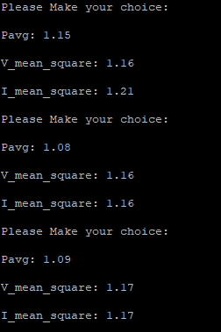

**Figure:** Putty outputs showing average power and V and I RMS calculations from ADC pins on MCU. MCU calculates with values taken from voltage and current sensors.

**6.2 Integration Test 2: Resonant Tank Output**

The engineering requirement that this test will accomplish is filtering the non-fundamental harmonics of the input square wave that will then produce a sinusoidal signal which then will be used to measure the voltage, current, and power via an ADC on the microcontroller. This test will not include any software, though the hardware element that we are testing is the ability to produce a sinusoidal wave which will then be used to measure voltage, current, and power.

Using the keysight oscilloscope we will measure the output of the resonant tank and ensure we can produce a sinusoidal wave from the output of the resonant tank. The max voltage and peak-to-peak voltage will be measured for values of a 48-volt max voltage (input square wave) and a 324-333 volt peak-to-peak output sine wave. The sine wave must be produced and the non-fundamental harmonics are filtered out and the max and peak-to-peak voltage reflect that of the input square wave to indicate success. If this is achieved then we have successfully implemented a resonant tank that filters out the higher harmonics to measure voltage, current, and power later on in the system.

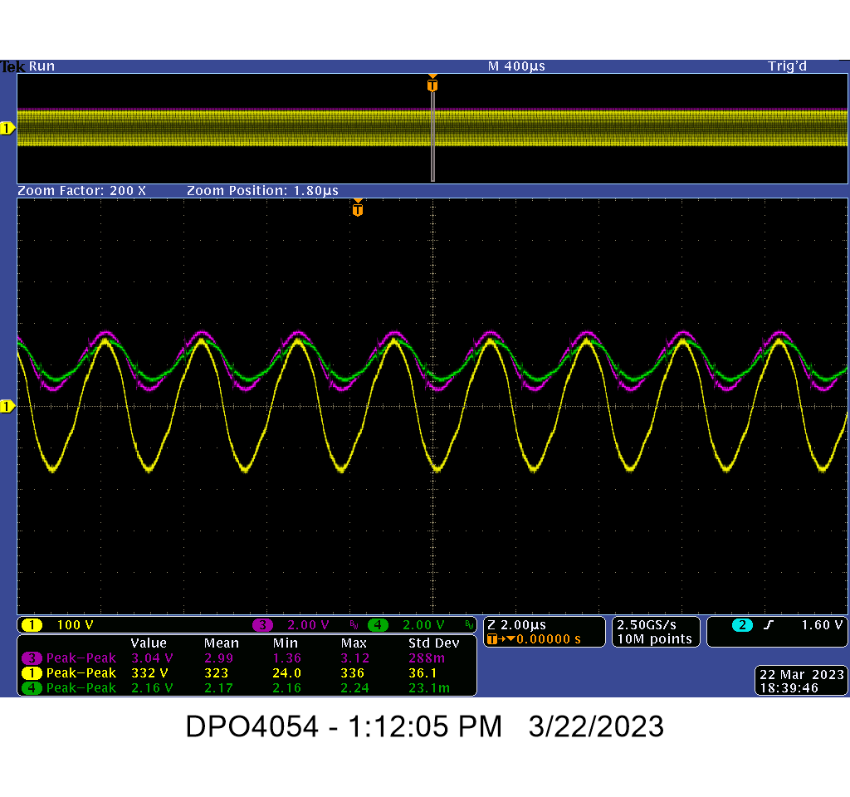

**Figure:** Open Circuit at 48 V- yellow is output of step-up transformer from the Resonant Tank, indicating a working transformer.

**6.3 Integration Test 3: Full System Integration**

The system integration test will demonstrate the full functionality of the system. We will demonstrate that the RF Tank will properly produce a sine wave with an amplitude corresponding to the input DC signal. We will also demonstrate the functionality of the IV sensors which will provide RMS IV measurements. The hardware includes the two custom built PCBs and the software comes from Code Composer Studio which will be used to send the PWM signals as well as do the ADC measurements. We will set up the system such that the two custom boards are connected together and all of the individual subsystems are working together. There are test points placed on both boards which will measure the four PWM signals, output of the phase-shifted full bridge, output of the RF Tank, output of the 1:2.5 transformer. From there, our output will first be open load then be connected to a 500 ohm power resistor which will act as our load. To be successful, our different subsystems must interact successfully in which they should produce the signals and values that match our given project requirements. The expected output will be a 320 V peak-to-peak 430 kHz sine wave based upon a 48V input from the power supply. Lower voltage values can also be tested and will have a corresponding expected output. In regards to the current, it will be dependent on the variable load (cauterizing tissue). There will be voltage and current sensors on the resonant tank board that will feed into the ADC pins of our microcontroller. The ADC pins will be used to measure voltage and current. The load on the output will vary from 50-2k ohms, for which the chassis power mount resistors will be used.

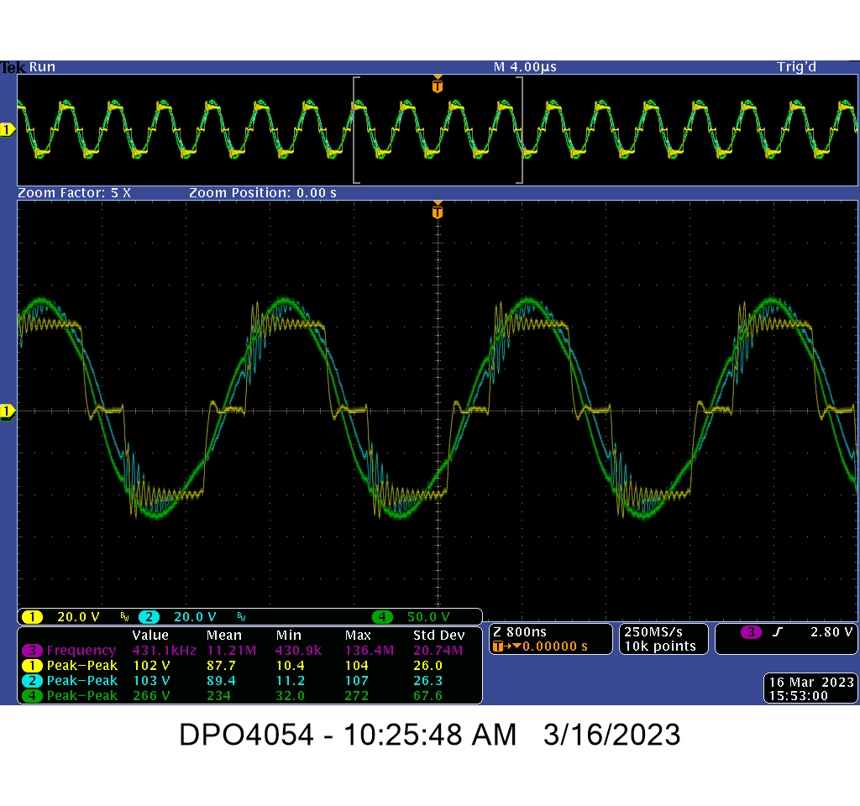

**Figure:** Scope shot of 40 V input. Yellow is the output of the phase-shifted full bridge. Blue is the output of the RF Tank. Green is the output of the step up 1:2.5 transformer. The scope is triggered on gpio8 (purple trace not shown on figure). This indicates a successful integration of the full bridge, RF tank, and step-up transformer.

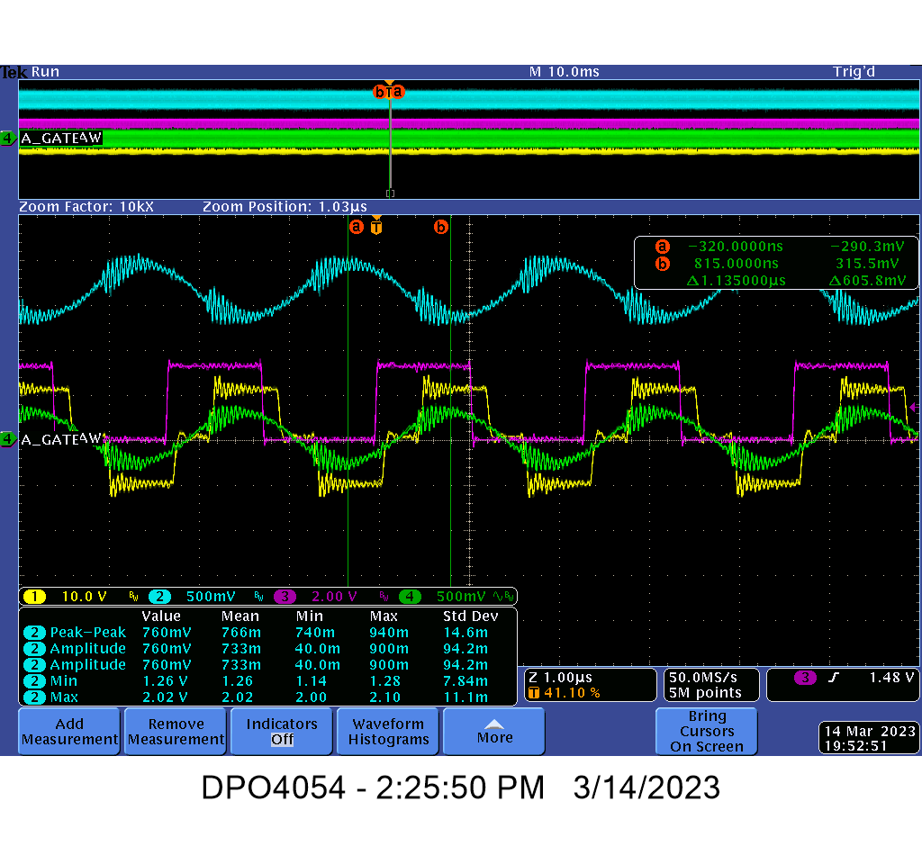

**Figure:** Scope shot of 10V input. Purple scope trace is the trigger at gpio8 (PWM signal) with the required square wave output. Yellow scope trace is the output of the phase-shifted full bridge with the required shift. The green scope trace is the output of the capacitive divider. Blue scope trace is the output of the voltage sensor with a 1.65V bias, showing intended inversion from the capacitive divider’s output.

**6.4 Power Budget**

50 W is needed for the bizact device to work as intended, but there are different power outputs depending on different loads. Our absolute highest power consumption will occur when our load is the lowest (50 Ohms). Our system (RF Tank) had a Thevenin equivalent resistance of approximately 25 Ohms: note, we had previously calculated that our Thevenin resistance should amount to approximately 23 Ohms. Taking this Thevenin equivalent resistance of our system, when connecting to a load, we found that we would get an open circuit voltage of approximately 108V across the load. Conversely, the maximum current we would see in our system would also correspond to this minimum load value which would be 2.16A. As a result, the power dissipated by the load would be 233.28 W. Another element of our system that would dissipate significant power is the sense resistor which would dissipate approximately 0.93W. Therefore, our system would dissipate approximately 234.21W maximum with the minimum load. The following is a MatLab simulation of the power curve with respect to the resistance of load:

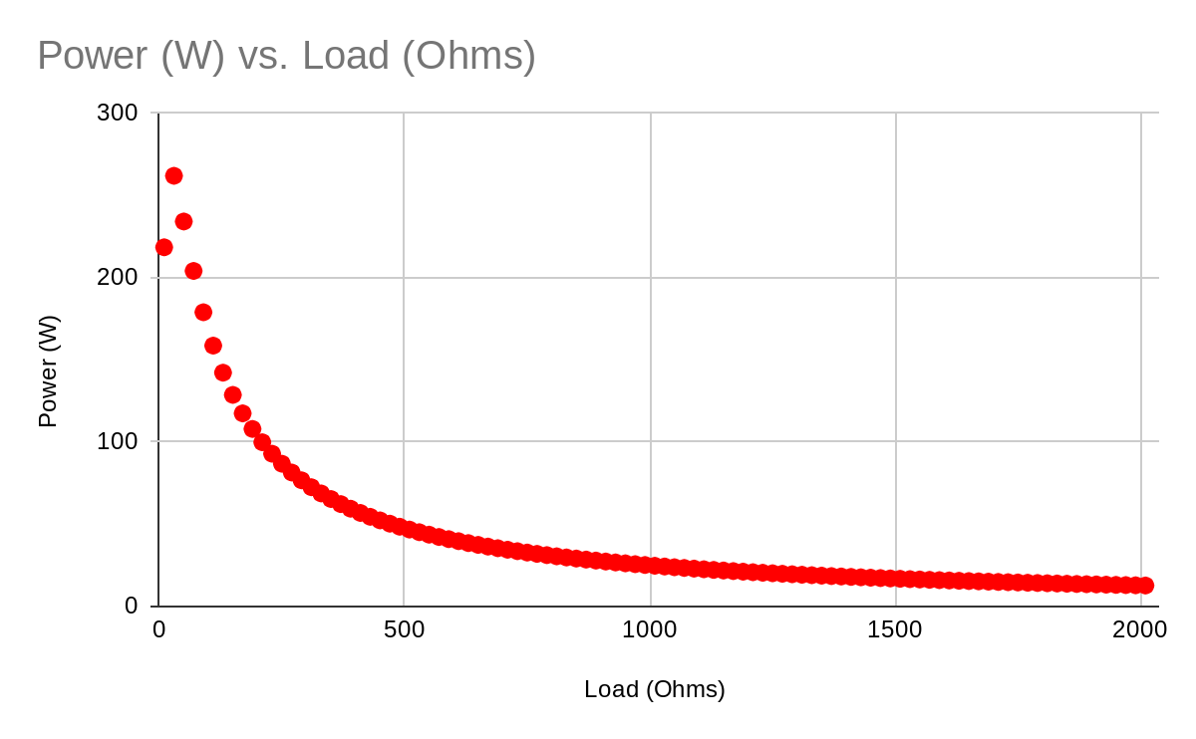

**6.5 User Interface**

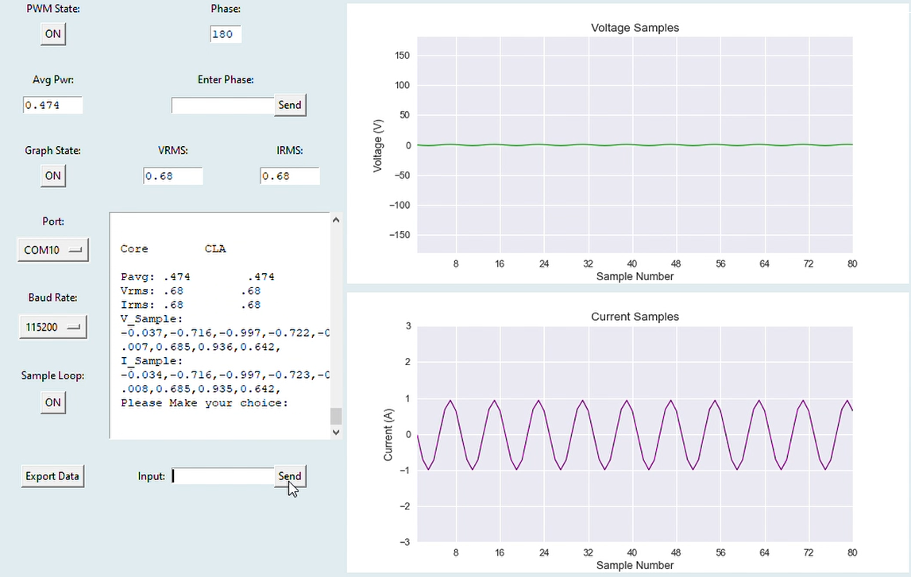

**Figure:** Finalized GUI. Complete with required voltage and current sample graphs on the right, and on the left the serial communication window and input bar, RMS and average power displays, phase display and phase change input bar, PWM on/off button, sample looping on/off button (for taking multiple cycles of samples given a single “get” instruction), a button to export all gathered and calculated data into a .xls file.

# **7 Schedule**

| **Date** | **Development Objective** |
| --- | --- |
| 10/13/22 | Complete Phased-Controlled Full-Bridge simulation (LTSpice) / Send eval. board for manufacturing |
| 10/27/22 | Complete Phase-Controlled Full-Bridge topology prototype / Serial monitoring initiated |
| 11/1/22 | Test evaluation board from Phase 1. Successful prototype generation of PWM gate drive signal using the TI Piccolo uC on custom PCB |
| 11/10/22 | Implement a resonant tank on a breadboard using Analog Discovery 2. Flashed the programmer into the board, compatible for power cycling. |
| 11/16/22 | Tested phase shifted full bridge on custom PCB. Implemented resonant tank prototype with the custom PCB phase shifted full bridge. |
| 11/21/22 | Tested the CLA ( Executed) code independently of main CPU  Test the ADC in CLA. Begun simulations/prototype current/voltage sensing circuit |
| 11/28/22 | Continued the ADC/ Continued simulation/prototype of IV sensors.. Implemented the prototype RF Tank with the I/V sensors. |
| 12/05/22 | Implement the open-loop system. Custom boards #2 sent for fabrication. |
| 1/12/23 | Complete current/voltage sensing circuit prototype |
| 1/26/23 | Complete the digital signal processing module with TI Piccolo uC |
| 2/17/23 | Complete implementation of HLA (TI Piccolo uC) controlling power modulation of RF tones. Constant Power/Constant Voltage/ Constant Current |
| 3/9/23 | Complete Firmware/Software Testing |
| 3/16/23 | Complete Integration Testing |
| 3/23/23 - 4/10/23 | Complete Holistic Device Testing |
| 4/28/23 | Engineering Expo |

# **8 Budget**

**TOTAL COSTS:** $1,216.22

**ITEM BREAKDOWN:**

| **Item Description** | **Manufacturer** | **Mfr Part Number** | **Unit Cost** | **Quantity** | **Cost** | **Shipping Cost** | **TOTAL COST** |
| --- | --- | --- | --- | --- | --- | --- | --- |
| MCU | Texas Instruments (Ti-Piccolo family) | F280049CPZS | $7.21 | 5 | $36.07 | $10.00 | $46.07 |
| Converters | Texas Instruments | LMR38010FDDAR | $2.30 | 5 | $11.48 | $10.00 | $21.48 |
| Gate Driver | Digi-Key | LM5101AMR | $3.40 | 40 | $136.00 | $6.99 | $142.99 |
| PCB 1 | JLC | NA | NA | 10 | $148.68 | $0.00 | $148.68 |
| Wall Power Converter | SoulBay | NA | NA | 4 | $54.64 | $0.00 | $54.64 |
| DROK 48V Power Supply | DROK | NA | 39.99 | 1 | $39.99 | $0.00 | $39.99 |
| Power MOSFET | TOSHIBA | TK3R2E06PL,S1X | $1.65 | 16 | $26.40 | $7.99 | $34.39 |
| Heat Sink | Easy Cargo | ES-TO-220-H10B201511 | $7.30 | 1 | $7.30 | $0.00 | $7.30 |
| PC Power Cord | Amazon Basics | NA | $6.94 | 1 | $6.94 | $0.00 | $6.94 |
| 100pcs Insulated Fork Spade Wire Connectors | MILAPEAK | NA | $7.89 | 1 | $7.89 | $0.00 | $7.89 |
| AD8031ARZ Opamps (for sensor buffering) | Analog Devices | 584-AD8031ARZ | $3.73 | 20 | $74.60 | $15.98 | $90.58 |
| 6037 Banana Jacks | Digi-Key | 36-6037-ND | $1.03 | 10 | $10.30 | $6.99 | $17.29 |
| Ferrite Bobbin | Digi-Key | 1779-1392-ND | $0.00 | 10 | $0.00 | $0.00 | BULK ORDER |
| Ferrite Core | Digi-Key | 1779-1208-ND | $0.00 | 10 | $0.00 | $0.00 | $86.15 |
| PCB 2 | JLC | NA | NA | 10 | $83.30 | $0.00 | $83.30 |
| Opamp Buffer Cap 1 | Mouser | 12062A150JAT2A | NA | 10 | $0.00 | $0.00 | BULK ORDER |
| Opamp Buffer Cap 2 | Mouser | GRM3195C2A162JA01D | NA | 10 | $0.00 | $0.00 | BULK ORDER |
| Opamp Buffer Cap 3 | Mouser | 12065A6R2CAT2A | NA | 10 | $0.00 | $0.00 | BULK ORDER |
| Opamp Buffer 10k Resistor | Mouser | HRG3216P-1002-D-T1 | NA | 20 | $0.00 | $0.00 | $31.60 |
| RF Tank Capacitors | Digi-Key | NA (See order XLS) | NA | NA | $0.00 | $0.00 | $51.03 |
| Heat Sink and Pad | Digi-Key | NA | NA | NA | $0.00 | $0.00 | $80.23 |
| Sense Resistor | Digi-Key | PF2203-0R2F1 | NA | 5 | $0.00 | $0.00 | $32.78 |
| Sensor Materials | Digi-Key | NA | NA | NA | $0.00 | $0.00 | $31.60 |
| MOSFETs | Digi-Key | IRF540NPBF | $0.00 | 10 | $0.00 | $0.00 | $22.16 |
| MOSFET Heat Sinks | Amazon | Antrader 6pcs 100mm x 25mm x 10mm Aluminum Heatsink for IC MOSFET SCR | $0.00 | 4 | $0.00 | $0.00 | $39.96 |
| Thermal Glue | Amazon | GENNEL G109 10 gram Thermal Conductive Glue | $0.00 | 1 | $0.00 | $0.00 | $11.99 |
| Magnetics 2 | Digi-Key | NA | NA | NA | $0.00 | $0.00 | $86.15 |
| RF Tank Capacitors 2 | Digi-Key | NA | NA | NA | $0.00 | $0.00 | $41.03 |
| **TOTAL** |  |  |  |  |  |  | **$1,216.22** |

# 

# **9 Acceptance Testing**

For this test, we will have our complete generator connected to a 500-ohm resistor as well as a laptop for viewing RMS values. We will have scope probes attached to the output of our system so that we can measure and display voltage to compare to our expected output. Using a 500 Ohm resistor, our system will output 50W +- 10% which meets our 3rd marketing requirement.

Our first marketing requirement (size of system) will also be covered in this test as our system must fit within a 6x12 inch box (unspecified height requirement). Our 2nd marketing requirement is our system should output a 324-334 V peak-to-peak with an input of 48V supply. Finally, our 4th marketing requirement will be met by showing our GUI displaying RMS values that align with the values displayed by oscilloscopes.

# 

# **10 Expo**

**10.1 Final System**

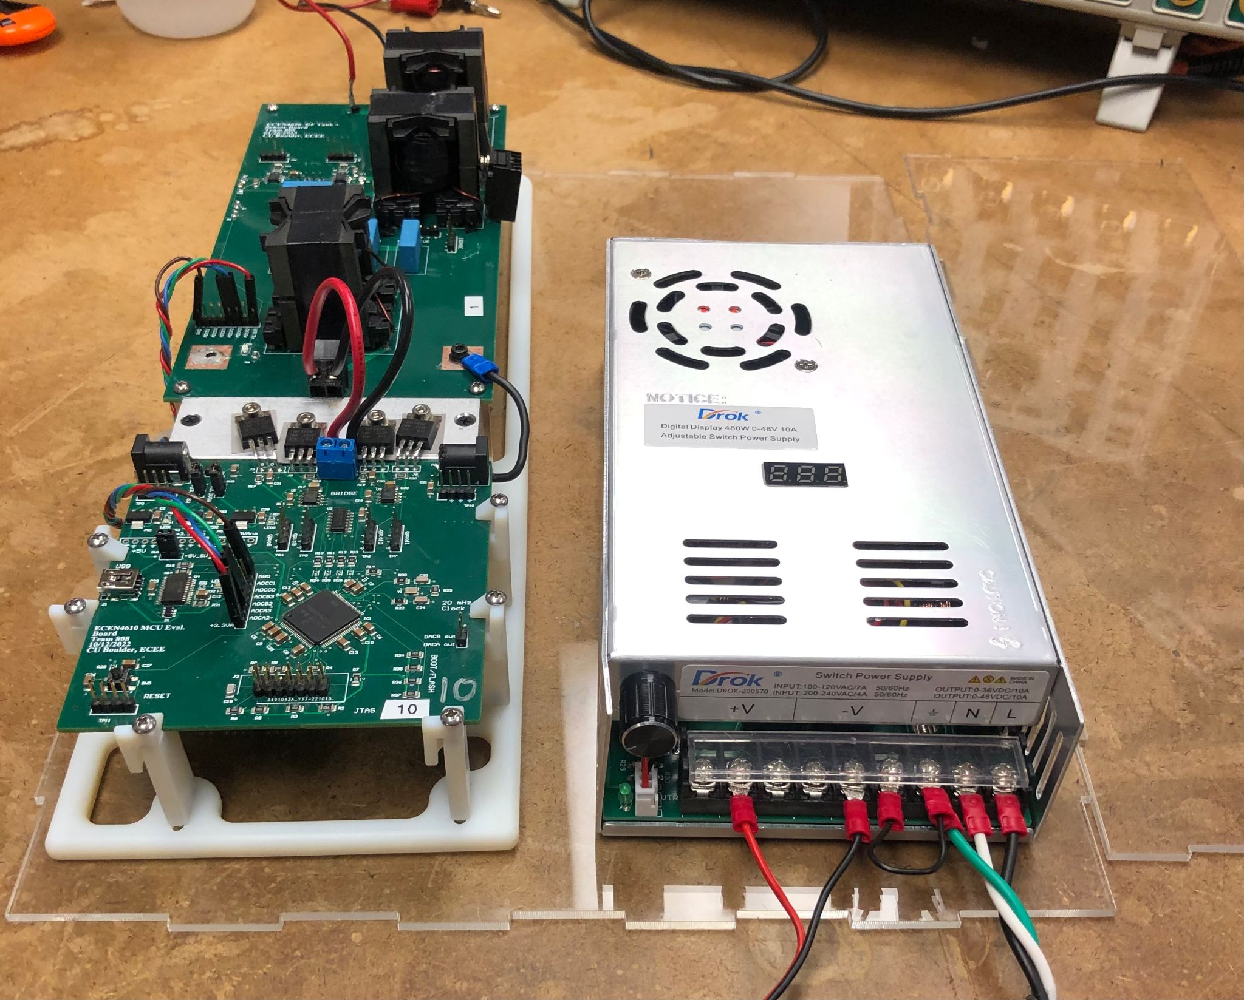

**Figure:** The final system with total integration as seen at Expo. Both PCBs are hooked up to one another (microcontroller in front, RF tank board behind it), with the power supply on the right.

**10.2 Setup Description**

Our setup at expo spanned 2 tables. On one end we had our scalable ESU setup, with our system connected to a provided bizact device and clamps suspending the saline soaked gauze and bacon used to demonstrate system functionality. An oscilloscope was hooked up to our system to view real-time value changes, with emphasis on the current sensor output. There were two computer monitors in use for audience viewing: one for the GUI and one connected to the oscilloscope. The other end had equipment not used in the product demo but important in understanding our design process. Because our ESU exists as a scaled down version of Medtronic’s existing FT10 generator, we had one at expo for reference. We also had extras of both PCBs. For the microcontroller board we provided a fully populated example, and for the tank board we provided a few copies of the blank, unpopulated version for the audience to handle. The power resistors we used in testing were there for show as well, and also as a backup so we would still have a working demonstration in case there were any issues with connecting the bizact at any time. We placed a third computer monitor with the two PCB schematics displayed on this end of the tables so anyone wanting a deeper technical understanding of the board design could choose to view them.

For the demonstration itself, we began by using the GUI to power on the PWM, and then connected the external power supply to the MCU board, after which we slowly turned the power up to the full 48V. Once ready, we clamped the bizact device around the saline soaked gauze and bacon, demonstrating not only the functionality of our ESU but also the use of the bizact itself for cauterization. From the gauze and bacon, audience members could see steam and cooked meat, respectively, indicating a working product. The values probed on the oscilloscope would change as the clamps closed around the gauze/bacon thus completing the circuit, and as the gauze/bacon’s physical properties changed as a result of the heating.

**10.3 Poster**

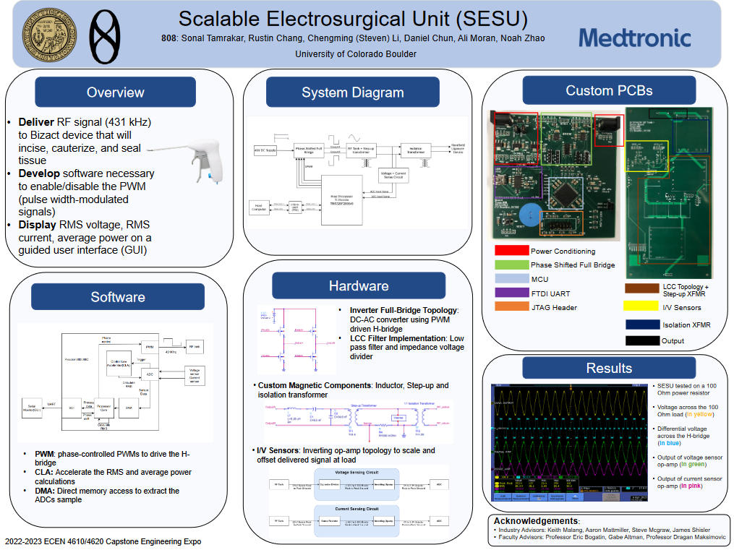

**Figure**: Our project poster for Expo

**10.4 Website Description**

The full website description is as follows:

**Team Name:** 808

**Team Members:**

Sonal Tamrakar, Rustin Chang, Chengming (Steven) Li, Daniel Chun, Ali Moran, Noah Zhao

**Sponsor:** Medtronic

**Hook of the project:** Revolutionizing electrosurgery: A cost-effective and compact

electrosurgical unit for accessible and life-saving procedures.

**Elevator Pitch:** Our project was to design and fabricate a generator device known as an

electrosurgical unit (ESU) used to supply an RF signal to another medical device known as the

Ligasure used in vessel sealing and tissue cauterization applications. Technological

advancements in electrosurgery such as the ESU and vessel sealing applications in the

developed world have been shown to reduce operation times, post-surgery pain, and expedited

recovery times. However, at the moment, many middle and lower-income countries do not have

access to ESU generators due to their high cost and large size. Therefore, the goal of our project

was to create a more accessible electrosurgical unit that was both cost-effective and space-

efficient while not compromising its vessel-sealing capabilities.

**Description of your product:** The signal that our ESU was required to provide was a 431 kHz

bipolar RF signal with an open circuit voltage of 324 V (± 10%). This signal would then be

delivered to the electrodes of the two-pronged jaw of the Ligasure device in which the tissue

site of interest (that is clamped down by the jaws) would then act as the effective load of our

system. Our system would be supplied with a 48 V DC signal which would either be provided by

a Medtronic-manufactured wall-to-system AC-DC converter or a 48V battery system. This DC

signal would be supplied to a phase-shifted full bridge (otherwise known as a full-bridge

inverter) in which the gate signals of each MOSFET would be controlled by PWM signals from

our TI Piccolo microcontroller. By taking the differential of each side of the bridge, the output

signal of the phase-shifted full bridge is a bipolar square wave AC signal of 431 kHz (peak-to-

peak 96 V). Depending on the PWM signal supplied to the gates of the MOSFETs, the user of our device (via GUI) can control the duty cycle of the square wave produced by the phase-shifted

full bridge which will vary the power output of our system: the variable input is known as the

Cphase (0-180 degrees) This output square wave AC signal will then be supplied to the next

circuit module of our system known as a resonant tank which consists of a low pass filter (LCC

topology with a cutoff at approximately 860 kHz) and a step-up transformer (turns ratio of 2.5).

After the resonant tank, all harmonics except the fundamental of the square wave signal

supplied by the phase-shifted full bridge should be attenuated (bipolar sine wave AC signal 431

kHz). Furthermore, in the case that we have a perfect square wave (Cphase input of 180

degrees), the bipolar sine wave output of the resonant tank will have a peak-to-peak voltage of

approximately 331V. The last circuit module is an isolation transformer (unity turns ratio) which

will provide a ground return path for the signal delivered to the tissue to ensure that no

electrical current is dissipated through the patient. The voltage and current delivered to the

load of our system (tissue) will be measured by a voltage and current sensor circuit topologies

which will feed a scaled-down signal back to the ADCs of our microcontroller to be displayed on

a serial port python GUI which will display real-time voltage and current graphs of the signal

delivered at the load.

**Acknowledgements:**

**Industry Advisors:** Keith Malang, Aaron Mattmiller, Steve Mcgraw, James Shisler

**Faculty Advisors:** Professor Eric Bogatin, Gabe Altman, Professor Dragan Maksimovic

**10.5 Lessons Learned**

Aside from the hands-on power electronics experience gained through the course of the project, our group learned the importance of communication. There were multiple times where we had received values from our sponsor that we did not follow up on, resulting in late stage system redesigns as the values we thought were required changed. Lack of follow up to communications also made it difficult for our sponsor to know we had received and understood data that had been sent to us, which caused further confusion. We learned that efficient and comprehensive communication within the team was essential as well, because despite having lab together twice a week there was a lot that went unsaid and misunderstood between team members. Clearing up the faults in our team communications, between both us and our sponsor and us as teammates, went a long way towards improving the working environment of labs and meetings, as well as improving total project comprehension and cohesion.